**Start a New Win32 Console Application**

Step 1. Run Microsoft Visual Studio 2010



Step 2. Menu "File"-"New"-"Project"

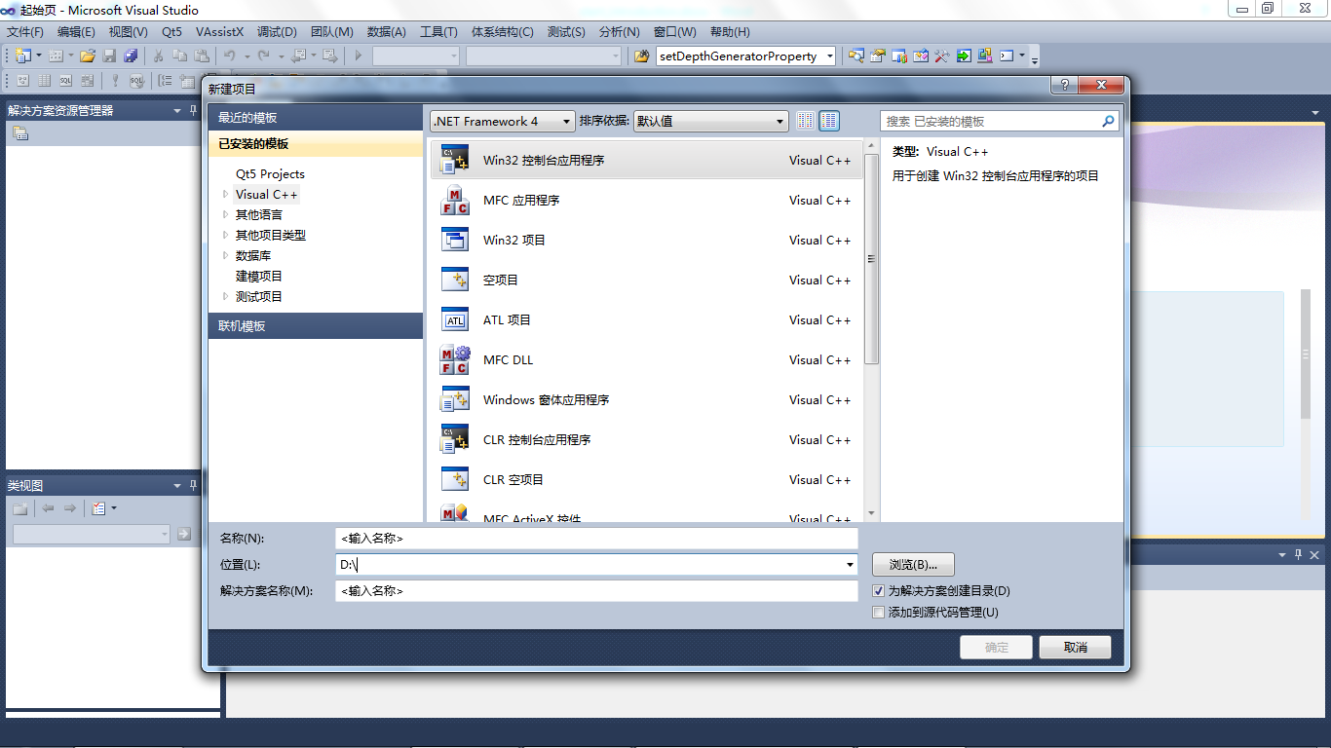

Step 3. Select "Win32 Console Application" in "Project" page, input/set "Location" and "Project name", then click "OK" button.

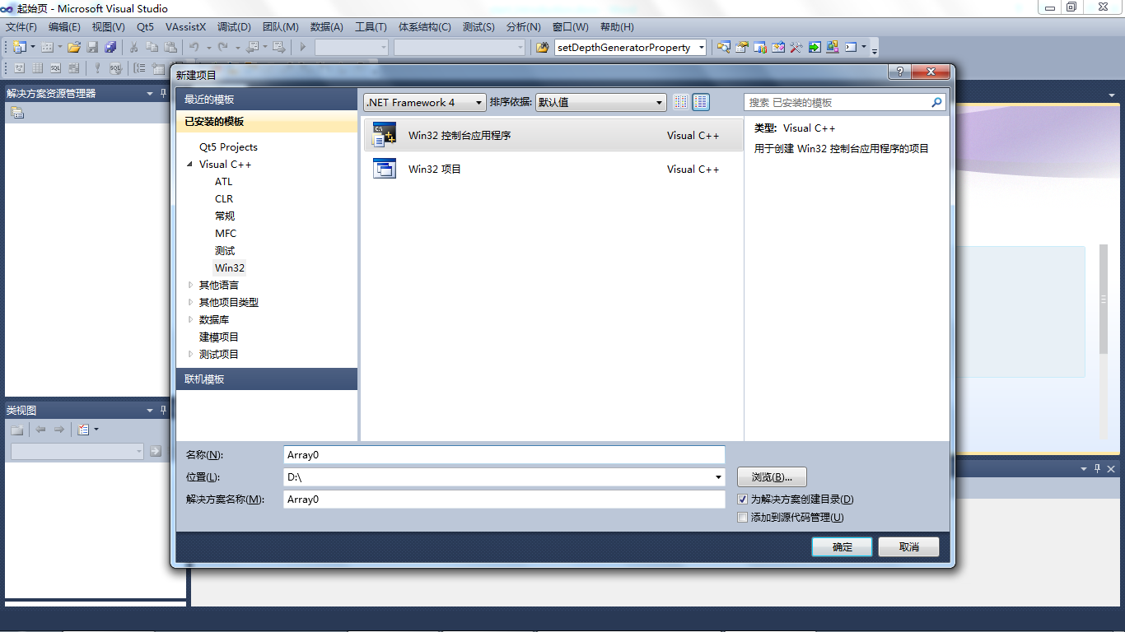

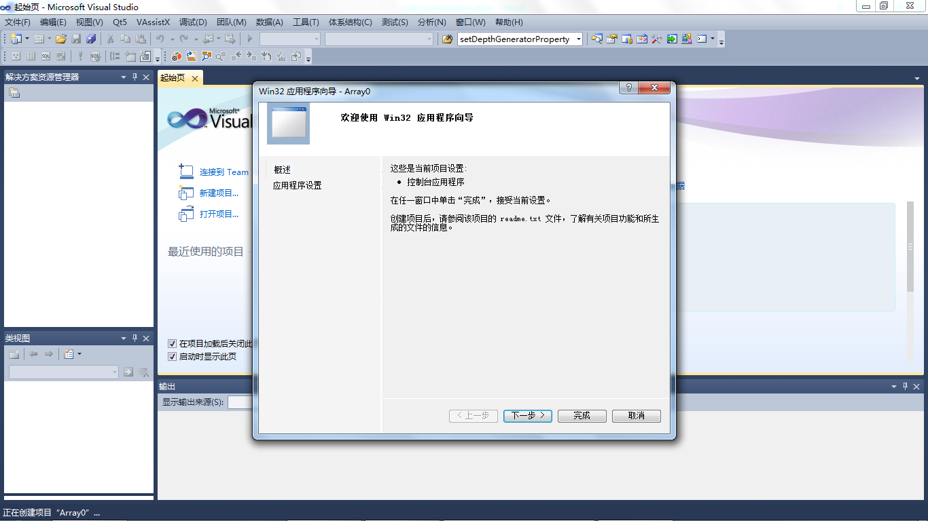

Step 4. Select "An empty project", then click "Finish".

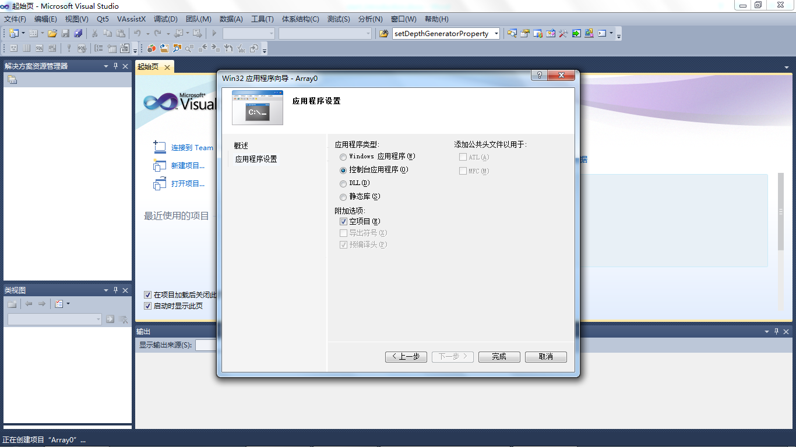

Step 5. A new empty win32 console application is created.

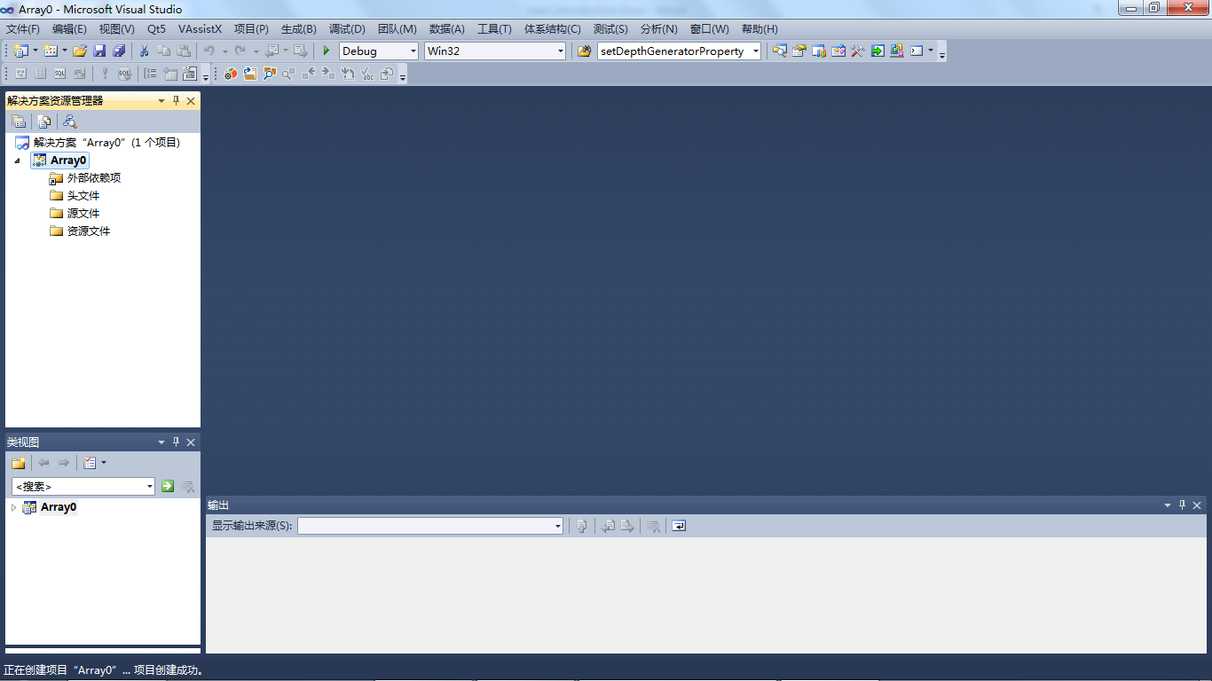

Step 7. Then you can add your own source code files. Select menu "Project"-"Add new term…". Select "C++ files" in "files" page. Set file name in "Name".

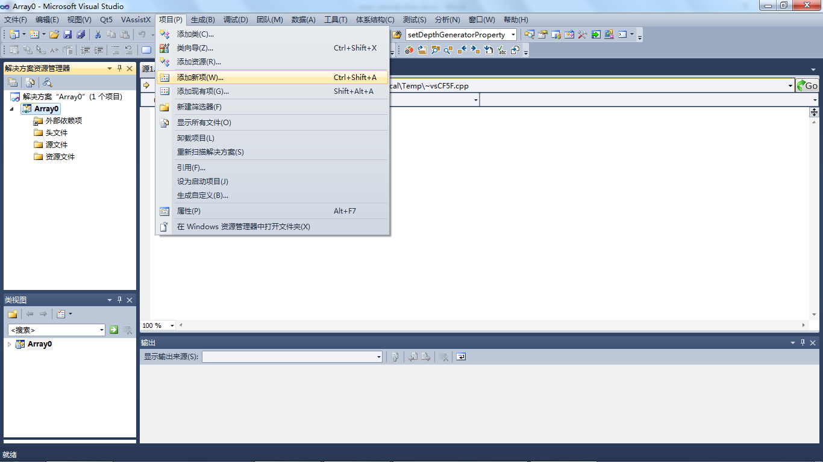

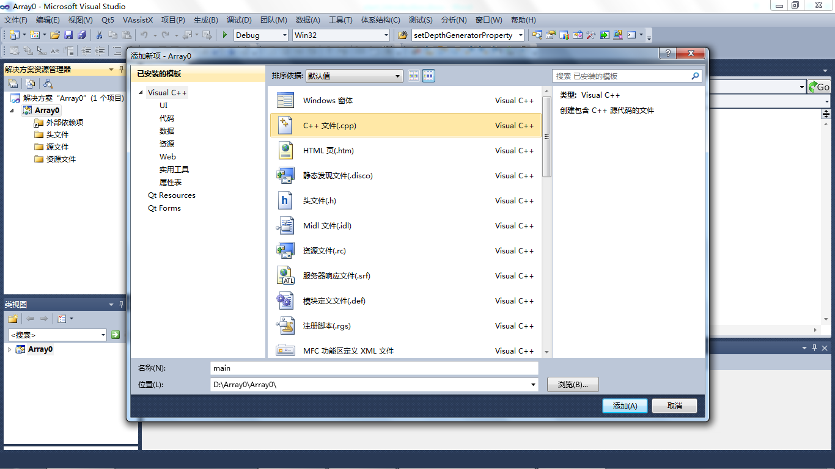

Step 8. Then you can start to write your own codes now.

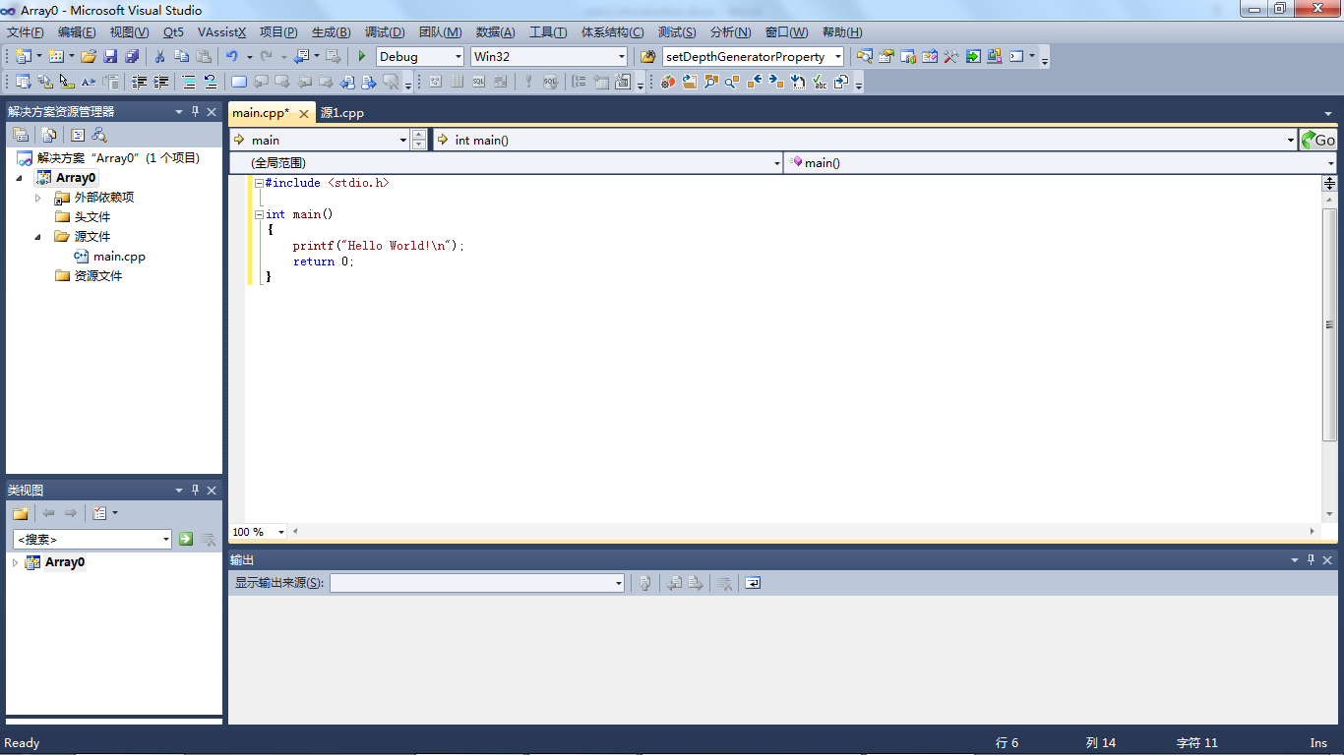

Step 9. Compile and run the program, then you can see the result:

